**End-of-course portfolio project introduction**

Each course in the Google Advanced Data Analytics Certificate concludes with a project that provides hands-on opportunities to practice your knowledge. These end-of-course portfolio projects build across courses to simulate the full lifecycle of a data project, just like job tasks that you will encounter as a data professional.

After completing all of the courses in this certificate program, you are encouraged to compile the projects in a portfolio that highlights your data analytics skills. You will learn how to create a portfolio in the final course of this certificate program: Google Advanced Data Analytics Capstone. In addition, the end-of-course projects can also be used to help you prepare for job applications and interviews since they showcase the valuable skills that you bring to the world of data analytics.

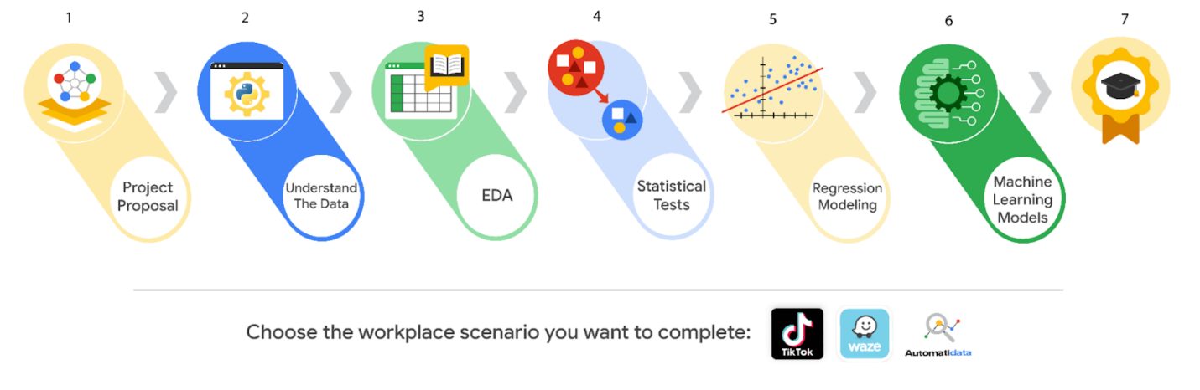

**Importance of communication in the data career space**

End-of-course projects emphasize technical and professional workplace skills, as well as the importance of communication in data analytics. The success of your workflow management, data analysis, data visualizations, statistics, regression analysis, and building machine learning models relies on your ability to communicate with cross-functional team members. So, each project is designed to help you develop critical communication skills that you’ll need to use on the job in order to effectively:

* Ask questions
* Share project needs
* Communicate with stakeholders
* Give and receive feedback
* Stay in contact with team members on the project

**Expectations**

As previously mentioned, you will encounter an end-of-course project in the final week of each course. The end-of-course projects were designed around a workplace scenario that will guide you through tasks that align with the concepts and skills you learned in each course. The workplace scenario extends across all of the certificate’s end-of-course projects.

You will be given the tools, resources, and instructions needed to apply your new skills and complete each individual end-of-course project. Additionally, you’ll also have access to helpful resources designed to guide and inspire your data analysis workflow. In the end, your effort will be rewarded with work examples that demonstrate the effectiveness of your data analysis. If you get stuck at any point, there are links to review relevant information within each course.

To help you complete each end-of-course project, you will receive a PACE (Plan, Analyze, Construct, and Execute) strategy document to guide your workflow. As you answer the questions, you will gain a deeper understanding of the data analysis process, document your growth as a data professional, and prepare the observations and reflections needed to complete each project.

**Start your project**

To complete the end-of-course portfolio project, you will first need to:

* Gather information about the business problem or question to be answered.
* Respond to key questions posed in the PACE strategy document.
* Create a project proposal for cross-functional team members.

In the next reading, you will learn about the workplace scenarios and how to get started on your end-of-course project. Good luck!

# Explore your Course 1 workplace scenarios

# ****Overview****

This certificate offers you a choice of several different workplace scenarios to use when completing each end-of-course project:

* Automatidata, featuring a fictional data consulting firm
* TikTok, created in partnership with the short-form video hosting company
* Waze, created in partnership with the realtime driving directions app

Each scenario offers you an opportunity to apply your skills and create work samples to share when applying for jobs; so, you will be practicing similar skills regardless of the workplace scenario. It is recommended that you work with the same scenario for each end-of-course project to have a cohesive experience. However, you are welcome to investigate any of the workplace scenarios you are interested in as you progress through the program.

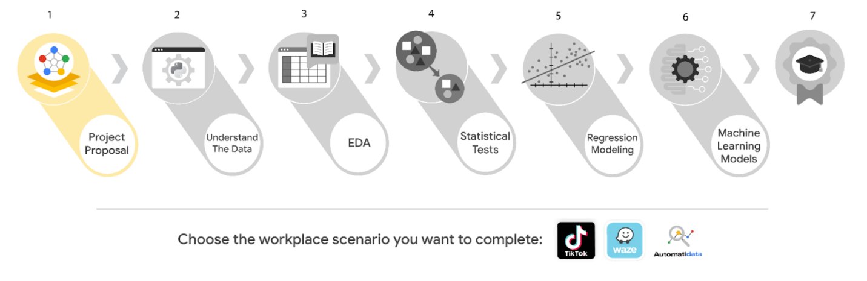

***Reminder:*** We recommend that you choose one workplace scenario to follow for all end-of-course projects to ensure end-to-end project development.

The minimum requirement to earn your Advanced Data Analytics Certificate is to complete the end-of-course project, using one workplace scenario, for each course. You may complete the project for as many of the workplace scenarios as you wish. Completing the project for more than one workplace scenario in a single course offers you additional practice and work examples you can add to your portfolio and share with prospective employers during your job search.

This reading offers an overview of all available workplace scenarios. Before moving on, identify the scenario you would like to complete for the Course 1 end-of-course project.

# ****Course 1 workplace scenarios****

## ****Automatidata****



**Project goal:**

In this fictional scenario, the New York City Taxi and Limousine Commission (TLC) has approached the data consulting firm Automatidata to develop an app that enables TLC riders to estimate the taxi fares in advance of their ride.

**Background:**

Since 1971, TLC has been regulating and overseeing the licensing of New York City's taxi cabs, for-hire vehicles, commuter vans, and paratransit vehicles.

**Scenario:**

You are a newly-hired data professional at Automatidata, a fictional data consulting firm. Automatidata’s focus is to help clients transform their unused and stored data into useful solutions. In this scenario, you will consult with The New York City Taxi & Limousine Commission to develop an app that will help users (TLC riders) estimate their taxi fares before their ride. Your first responsibility as a data analytics consultant will be to structure the necessary tasks into a project proposal that establishes milestones for the ride fare data project.

**Course 1 tasks:**

* Gather information from the notes from the last executive meeting of Automatidata
* Assign PACE stages to the requested tasks
* Organize tasks into milestones
* Create a project proposal for the executive team’s approval

***Note:*** The story, all names, characters, and incidents portrayed in this project are fictitious. No identification with actual persons (living or deceased) is intended or should be inferred. And, the data shared in this project has been created for pedagogical purposes.

## ****TikTok****



**Project goal:**

The TikTok data team is developing a machine learning model for classifying claims made in videos submitted to the platform.

**Background:**

TikTok is the leading destination for short-form mobile video. The platform is built to help imaginations thrive. TikTok's mission is to create a place for inclusive, joyful, and authentic content–where people can safely discover, create, and connect.

**Scenario:**

As a data analyst on TikTok's data team, with new considerations from the leadership team, you will create a project proposal by assigning the required data analytical tasks into realistic milestones that will advise future steps in the claims classification project.

**Course 1 tasks:**

* Gather information from stakeholder notes from within TikTok
* Assign PACE stages to the requested tasks for the classification project
* Organize tasks into milestones
* Create a project proposal for the TikTok data team

***Note:*** The story, all names, characters, and incidents portrayed in this project are fictitious. No identification with actual persons (living or deceased) is intended or should be inferred. And, the data shared in this project has been created for pedagogical purposes.

## ****Waze****



**Project goal:**

Waze leadership has asked your data team to develop a machine learning model to predict user churn. Churn quantifies the number of users who have uninstalled the Waze app or stopped using the app. This project focuses on monthly user churn. An accurate model will help prevent churn, improve user retention, and grow Waze’s business.

**Background:**

Waze’s free navigation app makes it easier for drivers around the world to get to where they want to go. Waze’s community of map editors, beta testers, translators, partners, and users helps make each drive better and safer.

**Scenario:**

You are the newest member of Waze’s data team. Your team is about to begin their user churn project. The first step is to create a project proposal. The proposal will clearly define the overall goal of the project, and identify key tasks, milestones, and stakeholders.

**Course 1 tasks:**

* Assign PACE stages to the requested tasks for the user churn project
* Organize tasks into milestones
* Create a project proposal for the Waze data team

***Note:*** The story, all names, characters, and incidents portrayed in this project are fictitious. No identification with actual persons (living or deceased) is intended or should be inferred. And, the data shared in this project has been created for pedagogical purposes.

# ****Key Takeaways****

In Course 1, Foundations of Data Science, you explored the world of data professionals and learned how data analysis contributes to an organization's goals.

### **Course 1 skills:**

* Effective communication
* Understand cross-functional team dynamics
* Project management
* Share insights and ideas with stakeholders

### **Course 1 end-of-course project deliverables:**

* Complete the Course 1 PACE strategy document
* Create a project proposal

The end-of-course portfolio projects are designed for you to apply your data analytical skills within a workplace scenario. No matter which scenario you work with, you will practice your ability to discuss data analytic topics with coworkers, internal team members, and external clients.

As a reminder, you are required to complete one project for each course. To gain additional practice, or to add more samples to your portfolio, you may complete as many of the scenarios as you wish.

# Course 1 end-of-course portfolio project overview: Automatidata

# ****Learn about the Course 1 Automatidata workplace scenario!****

The end-of-course project in Course 1 focuses on your ability to plan for data projects and create a project proposal. The end-of-course projects were designed with you in mind, offering an opportunity for you to practice and apply your data analytic skills. The materials provided here will guide you through discussions with co-workers, internal team members, and external stakeholders.

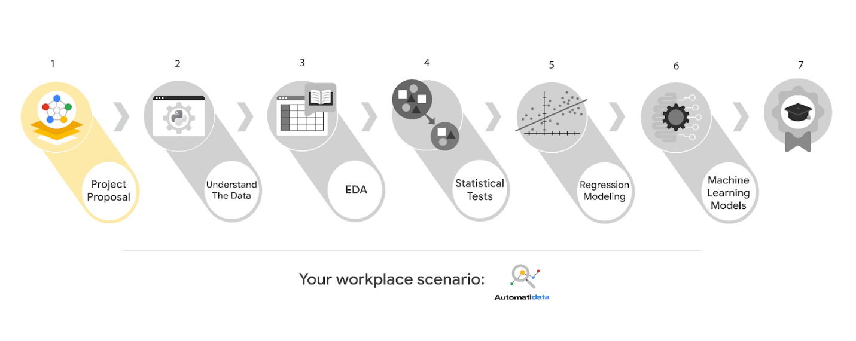

Learn more about the project, your role, and expectations in this reading.

## ****Background on the Automatidata scenario****

Congrats on your new job as a data analyst at a data consulting firm called Automatidata. Automatidata works with its clients to transform their unused and stored data into useful solutions, such as performance dashboards, customer-facing tools, strategic business insights, and more. They specialize in identifying a client’s business needs and utilizing their data to meet those business needs.

Automatidata is consulting for the New York City Taxi and Limousine Commission (TLC). New York City TLC is an agency responsible for licensing and regulating New York City's taxi cabs and for-hire vehicles. The agency has partnered with Automatidata to develop a regression model that helps estimate taxi fares before the ride, based on data that TLC has gathered.

The TLC data comes from over 200,000 taxi and limousine licensees, making approximately one million combined trips per day.

**Note:**This project's dataset was created for pedagogical purposes and may not be indicative of New York City taxi cab riders' behavior.

### **Project background**

Automatidata is in the earliest stages of the TLC project. The following tasks are needed before the team can begin the data analysis process:

* A project proposal identifying the following:
  + Organize project tasks into milestones
  + Classify tasks using the PACE workflow
  + Identify relevant stakeholders

### **Your assignment**

For your first assignment, Automatidata will need a project proposal that will create milestones for the tasks within the TLC project. Remember to take into account your audience, team, project goal, and PACE stages of each task in planning your project deliverable.

## ****Team members at Automatidata and the New York City TLC****

### **Automatidata Team Members**

* Udo Bankole, Director of Data Analysis
* Deshawn Washington, Data Analysis Manager
* Luana Rodriquez, Senior Data Analyst
* Uli King, Senior Project Manager

Your teammates at Automatidata have technical experience with data analysis and data science. However, you should always be sure to keep summaries and messages to these team members concise and to the point.

### **New York City TLC Team Members**

* Juliana Soto, Finance and Administration Department Head
* Titus Nelson, Operations Manager

***Note:*** The story, all names, characters, and incidents portrayed in this project are fictitious. No identification with actual persons (living or deceased) is intended or should be inferred. The data shared in this project has been altered for pedagogical purposes.

The TLC team members are program managers who oversee operations at the organization. Their roles are not highly technical, so be sure to adjust your language and explanation accordingly.

## ****Meeting notes****

Now that you are working as Automatidata’s latest data analytics professional, you are given access to the company network and set up with a company email account (your first initial and last name, followed by @automatidata.org).

Opening your inbox, you notice an email from your supervisor, Deshawn.

**From:** Deshawn Washington

**Subject:** Review meeting notes

If you are able to read this, then your company accounts have been created! Now is the perfect time to get started. Last week, I attended an internal meeting with our leadership team about a new project we are about to begin. You’ll receive more information in the next few days, but I would like you to be aware of some needs that were identified by our leadership team. Here is an excerpt from the notes I took during the Automatidata leadership team meeting. I’ve organized the points by the person who made them.

Uli King  (Senior Project Manager)

* The data team will need a global-level project document to outline the goals and milestones.
* I am working closely with Titus Nelson over at the New York City Taxi and Limo Commission. He has requested some visuals to share with TLC’s executives.

Luana Rodriquez (Senior Data Analyst)

* The dataset from TLC has to be inspected before any analysis can begin.
* Our team needs to determine what information the TLC data provides through exploratory data analysis (EDA).
* Eventually, our team will need to test to find if the model is delivering consistent results.

Udo Bankole (Director of Data Analysis)

* Before we present any insights to TLC, we'll need to determine whether or not the model we produce meets the project requirements.
* Once we have a final model, I'll need to know the main talking points going into our presentation with TLC.

My thoughts and concerns…

* I think it's best to use Python for the TLC project. I'll have someone on my team set that up as soon as we have the plan in place.
* It will be important to establish the relationship between any variables within the TLC data. I'd suggest the data team consider A/B testing, since that will analyze the relationship between the two most useful variables and subsequently provide data-driven support for future business decisions.

Review the meeting notes above to become familiar with the project’s context. I’ll ask you to identify project tasks and come up with a structure to guide the data team through this project. After our discussion about your experience in the certificate program offered by Google, I know that your efficient communication style and problem-solving will enhance the abilities of the data team.

There will be more details sent to you very soon.

Welcome to the team,

Deshawn Washington

Data Analysis Manager

Automatidata

(P.S. There will be muffins in the break room every Tuesday morning. Be early…unless you like bran muffins. LOL)

## ****Specific project deliverables****

With this end-of-course project, you will gain valuable practice and apply your new skills as you complete the following:

* Course 1 PACE Strategy Document to plan your project while considering your audience members, teammates, key milestones, and overall project goal.
* Create a project proposal for the data team.

## ****Key takeaways****

The Google Advanced Data Analytics Certificate end-of-course project is designed for you to practice and apply course skills in a fictional workplace scenario. By completing each course’s end-of-course project, you will have work examples that will enhance your portfolio and showcase your skills for future employers.

# Activity Exemplar: Create your Course 1 Automatidata project

Here are completed exemplars along with an explanation of how the exemplars fulfill the expectations for the activity.

## Completed Exemplars



To review the exemplars for this course item, click the following link and select Use Template.

Link to exemplars:

* [Course 1 PACE strategy document](https://docs.google.com/document/d/1vQAji1vQtK1-IdypxBg1g3K-dTu4mXcBlxC572eSwZM/template/preview)
* [Automatidata project proposal](https://docs.google.com/document/d/1ru7p_XahBMHah9ELzSIoEcBzsWdMp0SGczI19EgP7XI/template/preview)

OR

If you don’t have a Google account, you can download the exemplars directly from the following attachments.

[Activity Exemplar\_ Course 1 PACE strategy document](https://d3c33hcgiwev3.cloudfront.net/cTL5pdsBRHup2vz-ICngHg_a35616e6a3894b5c972b55a059bc2ff1_Activity-Exemplar_-Course-1-PACE-strategy-document.docx?Expires=1688083200&Signature=DGs-moJ6qtPllgUpiX9iRniqRhuqetmDm1dOhT5imlZK5Le63RWS4VtKzTazko33ZiXxspyXERZW0kMFTCn2ZI0vFjcP8jUMOvW1v8M1iwNDJ89GvkbfuB3C-eP1EDASdxgfjPzrS~9fbrod6dQvEPtNnKbG7dKV3f3v7RtJoTc_&Key-Pair-Id=APKAJLTNE6QMUY6HBC5A" \t "_blank)

[DOCX File](https://d3c33hcgiwev3.cloudfront.net/cTL5pdsBRHup2vz-ICngHg_a35616e6a3894b5c972b55a059bc2ff1_Activity-Exemplar_-Course-1-PACE-strategy-document.docx?Expires=1688083200&Signature=DGs-moJ6qtPllgUpiX9iRniqRhuqetmDm1dOhT5imlZK5Le63RWS4VtKzTazko33ZiXxspyXERZW0kMFTCn2ZI0vFjcP8jUMOvW1v8M1iwNDJ89GvkbfuB3C-eP1EDASdxgfjPzrS~9fbrod6dQvEPtNnKbG7dKV3f3v7RtJoTc_&Key-Pair-Id=APKAJLTNE6QMUY6HBC5A" \t "_blank)

[Activity Exemplar\_ Automatidata project proposal](https://d3c33hcgiwev3.cloudfront.net/n5GHgyU2SdKRk_4a04-qug_c38fb96043ec4fb696bd5404f7d66bf1_Activity-Exemplar_-Automatidata-project-proposal.docx?Expires=1688083200&Signature=VS8BPltSgkNZLELsT0HXe1IesJ~sKvRZlzMDfuAhD0CP8rvIBiCmal5onPD1iqpSJsXAS8InA7yZRQoALDSDyWcDEAJEK~ohI7b5c23wM7jOVXlt2bV~XiAv6A8Jm2cfMt0HbsDTse6~PMu~RyvIjR1m-roa7mYFfxS8G0CwzJo_&Key-Pair-Id=APKAJLTNE6QMUY6HBC5A" \t "_blank)

[DOCX File](https://d3c33hcgiwev3.cloudfront.net/n5GHgyU2SdKRk_4a04-qug_c38fb96043ec4fb696bd5404f7d66bf1_Activity-Exemplar_-Automatidata-project-proposal.docx?Expires=1688083200&Signature=VS8BPltSgkNZLELsT0HXe1IesJ~sKvRZlzMDfuAhD0CP8rvIBiCmal5onPD1iqpSJsXAS8InA7yZRQoALDSDyWcDEAJEK~ohI7b5c23wM7jOVXlt2bV~XiAv6A8Jm2cfMt0HbsDTse6~PMu~RyvIjR1m-roa7mYFfxS8G0CwzJo_&Key-Pair-Id=APKAJLTNE6QMUY6HBC5A" \t "_blank)

## Assessment of Exemplars



### Course 1 PACE strategy document

Compare the exemplar to your completed PACE strategy document. Your responses may differ from the exemplar, but that is to be expected. What did you do well? Where can you improve? Use your answers to these questions to guide you as you progress through the course.

***Note:*** The exemplar represents one possible way to address the PACE questions and classify project tasks according to the PACE workflow. Yours might differ in certain ways, such as your specific responses to questions. What’s important is that you have a general idea of the order and PACE-stage classification for tasks in the data analysis process.

Your replies to the Course 1 PACE strategy document should:

* Be relevant to the Automatidata project goals and related to data science
* Demonstrate your understanding and assessment of the business scenario
* Communicate the reasoning behind your decisions to pair PACE stages with specific tasks



### Course 1 Automatidata project proposal

Compare the exemplar to the Automatidata project proposal you completed. Review your work using each of the criteria in the exemplar. What did you do well? Where can you improve? Use your answers to these questions to guide you as you progress through the course.

***Note:*** The exemplar represents one possible way to complete the Automatidata project proposal. Yours might differ in certain ways, such as specific task assignments, PACE stages, or relevant stakeholders. What’s important is that you have an overall understanding of the purpose and organization of project proposals for data-driven work.

Your project proposal should:

* Clearly communicate the overall project goal
* Identify key tasks, milestones, and stakeholders

# Course 1 end-of-course portfolio project overview: TikTok

# ****Learn about the Course 1 TikTok workplace scenario!****

This end-of-course project was designed with you in mind, creating an opportunity for you to practice and apply your data analytic skills. The materials provided here will guide you through discussions with co-workers, internal team members, and external stakeholders.

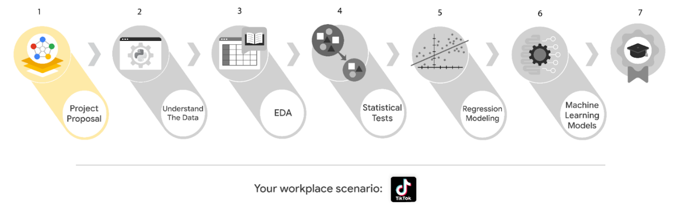

Learn more about the project, your role, and expectations in this reading.

## ****Background on the TikTok scenario****

Welcome to your new role at TikTok! We’re thrilled to have you on the data team!

At TikTok, our mission is to inspire creativity and bring joy. Our employees lead with curiosity and move at the speed of culture. Combined with our company's flat structure, you'll be given dynamic opportunities to make a real impact on a rapidly expanding company and grow your career.

TikTok users have the ability to report videos and comments that contain user claims. These reports identify content that needs to be reviewed by moderators. This process generates a large number of user reports that are difficult to address quickly.

TikTok is working on the development of a predictive model that can determine whether a video contains a claim or offers an opinion. With a successful prediction model, TikTok can reduce the backlog of user reports and prioritize them more efficiently.

### **Project background**

TikTok’s data team is in the earliest stages of the claims classification project. The following tasks are needed before the team can begin the data analysis process:

* A project proposal identifying the following:
  + Organize project tasks into milestones
  + Classify tasks using the PACE workflow
  + Identify relevant stakeholders

### **Your** **assignment**

For your first assignment, TikTok is asking for a project proposal that will create milestones for the tasks within the comment classification project. Remember to take into account your audience, team, project goal, and PACE stages of each task in planning your project deliverable.

## ****Team members at TikTok****

As a new data analyst, you’ll work closely with a talented team of experienced data professionals. You’ll also collaborate with TikTok co-workers outside the data team as your project requires.

### **Data team roles**

* Willow Jaffey- Data Science Lead
* Rosie Mae Bradshaw- Data Science Manager
* Orion Rainier- Data Scientist

### **Cross-functional team members**

* Mary Joanna Rodgers- Project Management Officer
* Margery Adebowale- Finance Lead, Americas
* Maika Abadi- Operations Lead

***Note:*** The story, all names, characters, and incidents portrayed in this project are fictitious. No identification with actual persons (living or deceased) is intended or should be inferred. The data shared in this project has been altered for pedagogical purposes.

Your TikTok team includes several managers overseeing operations. It is important to adapt your communication to their roles since their responsibilities are less technical. The members of the data team at TikTok are well versed in data analysis and data science. Messages to these more technical co-workers should be concise and specific.

## ****Meeting notes****

Now that you are onboard, you have access to the company network and are set up with a company email account.

You notice an email from your supervisor at the top of your inbox.

**From:** Rosie Mae Bradshaw

**Subject:** Your first task: Review meeting notes

If you are able to read this, then your company accounts have been created! It’s the perfect time to get started with your first task. Last week, I attended an internal meeting with our leadership team about a new project we are about to begin. You’ll receive more information in the next few days, but I would like you to be aware of some needs that were identified by our leadership. Here is an excerpt from the notes I took during the leadership team meeting. I’ve organized the points by the individual who made the comment:

Mary Joanna Rodgers- Project Management Officer

* The project will need a global document identifying deliverables & milestones.
* We will need to generate some visuals to share with TikTok executives.

Orion Rainier-Data Scientist

* We will need to have an understanding of the data we will be working with on this project.
* It will require someone on the team to inspect the dataset for missing data.
* The data team needs to determine what information will be the most useful in TikTok’s data through exploratory data analysis (EDA).
* Eventually, our team will need to run some method of statistical testing.

Willow Jaffey- Data Science Lead

* The goal of the claim classification project is to build and deliver a reliable machine learning model.
* The team will need to determine the type of regression model for this project.
* Once we have a final model, I'll need to know the main talking points going into our presentation to the leadership team.
* The team will need to determine the best method of hypothesis testing for this dataset.

My thoughts and concerns…

* I think it's best to use Python for this project. I'll have someone on my team set that up as soon as we have the project proposal in place.
* I'd suggest the data team will need to check the assumptions made by any regression modeling developed for this project.
* The data team will identify and set up the project’s workflow.

There will be more details sent to you very soon.

Welcome to the team,

Rosie Mae Bradshaw

Data Science Manager

TikTok

(P.S. Don’t forget about the company-sponsored lunch on Friday. The food is always fantastic. It’s a great opportunity to meet more of our wonderful co-workers. Our team meets in the lobby around noon. Please join us!)

## ****Specific project deliverables****

With this end-of-course project, you will gain valuable practice and apply your new skills as you complete the following deliverables:

* Course 1 PACE Strategy Document to plan your project while considering your audience members, teammates, key milestones, and overall project goal.
* Create a project proposal for the data team.

## ****Key takeaways****

The Google Advanced Data Analytics Certificate end-of-course project is designed for you to practice and apply course skills in a fictional workplace scenario. By completing each project, you will have work examples that will enhance your portfolio and showcase your skills for future employers.

# Activity Exemplar: Create your Course 1 TikTok project

Here are completed exemplars along with an explanation of how the exemplars fulfill the expectations for the activity.

## Completed Exemplars



To review the exemplars for this course item, click the following link and select Use Template.

Link to exemplars:

* [Activity Exemplar: Course 1 PACE strategy document](https://docs.google.com/document/d/1vQAji1vQtK1-IdypxBg1g3K-dTu4mXcBlxC572eSwZM/template/preview)
* [Activity Exemplar: TikTok project proposal](https://docs.google.com/document/d/1csbxKOyfFLCIFltyhvP2AHT5-f7VGG2cH86xybEPUGQ/template/preview)

OR

If you do not have a Google account, you can download the exemplars directly from the attachment below.

[Activity Exemplar\_ TikTok project proposal](https://d3c33hcgiwev3.cloudfront.net/dZtaSV0tQOajL2mX-VRDVA_33a3cf060e8947428f3844f65495a7f1_Activity-Exemplar_-TikTok-project-proposal.docx?Expires=1688083200&Signature=StHoGf92rSasRjQQgtdzKYHkqm94FvhX~-~mzV1zjhOInh0gYbPwzvbq0WzrjXOV3CyuHfoih0OY9BF6tgYA2Y8Ick21l-gqWF1B0D6RS7nWDyhXjbpccLii1dTRELE-eGMatwOXyhOsOHrNWMR09-JG1xQs8EaYmexwpWLegxE_&Key-Pair-Id=APKAJLTNE6QMUY6HBC5A" \t "_blank)

[DOCX File](https://d3c33hcgiwev3.cloudfront.net/dZtaSV0tQOajL2mX-VRDVA_33a3cf060e8947428f3844f65495a7f1_Activity-Exemplar_-TikTok-project-proposal.docx?Expires=1688083200&Signature=StHoGf92rSasRjQQgtdzKYHkqm94FvhX~-~mzV1zjhOInh0gYbPwzvbq0WzrjXOV3CyuHfoih0OY9BF6tgYA2Y8Ick21l-gqWF1B0D6RS7nWDyhXjbpccLii1dTRELE-eGMatwOXyhOsOHrNWMR09-JG1xQs8EaYmexwpWLegxE_&Key-Pair-Id=APKAJLTNE6QMUY6HBC5A" \t "_blank)

[Activity Exemplar\_ Course 1 PACE strategy document](https://d3c33hcgiwev3.cloudfront.net/fxwpLZWoQHiEvv6eqwGlMg_791d1bfa00fb45218c82206beba631f1_Activity-Exemplar_-Course-1-PACE-strategy-document.docx?Expires=1688083200&Signature=jiF3D1e8guj5IH~K0DSGYn7xO0JyumO0-nx7NDnI3yOFbhM2xitS7ppYunfKjOfb5RGKjyi2CcGWLMXh7S7-bbWC-MuIZ-Fjtd~De6fIZpN3uqBgEhLGT5K~lz~ZBB9kV9NtgwQC8OEi5NcouEdpAhLCw8XGqIoh~XJERU-WQBs_&Key-Pair-Id=APKAJLTNE6QMUY6HBC5A" \t "_blank)

[DOCX File](https://d3c33hcgiwev3.cloudfront.net/fxwpLZWoQHiEvv6eqwGlMg_791d1bfa00fb45218c82206beba631f1_Activity-Exemplar_-Course-1-PACE-strategy-document.docx?Expires=1688083200&Signature=jiF3D1e8guj5IH~K0DSGYn7xO0JyumO0-nx7NDnI3yOFbhM2xitS7ppYunfKjOfb5RGKjyi2CcGWLMXh7S7-bbWC-MuIZ-Fjtd~De6fIZpN3uqBgEhLGT5K~lz~ZBB9kV9NtgwQC8OEi5NcouEdpAhLCw8XGqIoh~XJERU-WQBs_&Key-Pair-Id=APKAJLTNE6QMUY6HBC5A" \t "_blank)

## Assessment of Exemplar



### Course 1 PACE strategy document

Compare the exemplar to your completed PACE strategy document. Your responses may differ from the exemplar, but that is to be expected. What did you do well? Where can you improve? Use your answers to these questions to guide you as you progress through the course.

***Note:*** The exemplar represents one possible way to address the PACE questions and classify project tasks according to the PACE workflow. Yours might differ in certain ways, such as your specific responses to questions. What’s important is that you have a general idea of the order and PACE-stage classification for tasks in the data analysis process.

Your replies to the Course 1 PACE strategy document should:

* Be relevant to the TikTok project goals and related to data science
* Demonstrate your understanding and assessment of the business scenario
* Communicate the reasoning behind your decisions to pair PACE stages with specific tasks



### Course 1 TikTok project proposal

Compare the exemplar to the TikTok project proposal you completed. Review your work using each of the criteria in the exemplar. What did you do well? Where can you improve? Use your answers to these questions to guide you as you continue to progress through the course.

***Note:*** The exemplar represents one possible way to complete the TikTok project proposal. Yours might differ in certain ways, such as specific task assignments, PACE stages, or relevant stakeholders. What’s important is that you have an overall understanding of the purpose and organization of project proposals for data-driven work.

Your project proposal should:

* Clearly communicate the overall project goal
* Identify key tasks, milestones, and stakeholders

# Course 1 end-of-course portfolio project overview: Waze

# ****Learn about the Course 1 Waze workplace scenario!****

The end-of-course project in Course 1 focuses on your ability to plan for data projects and create a project proposal. The end-of-course projects were designed with you in mind, offering an opportunity for you to practice and apply your data analytic skills. The materials provided here will guide you through discussions with co-workers, internal team members, and external stakeholders.

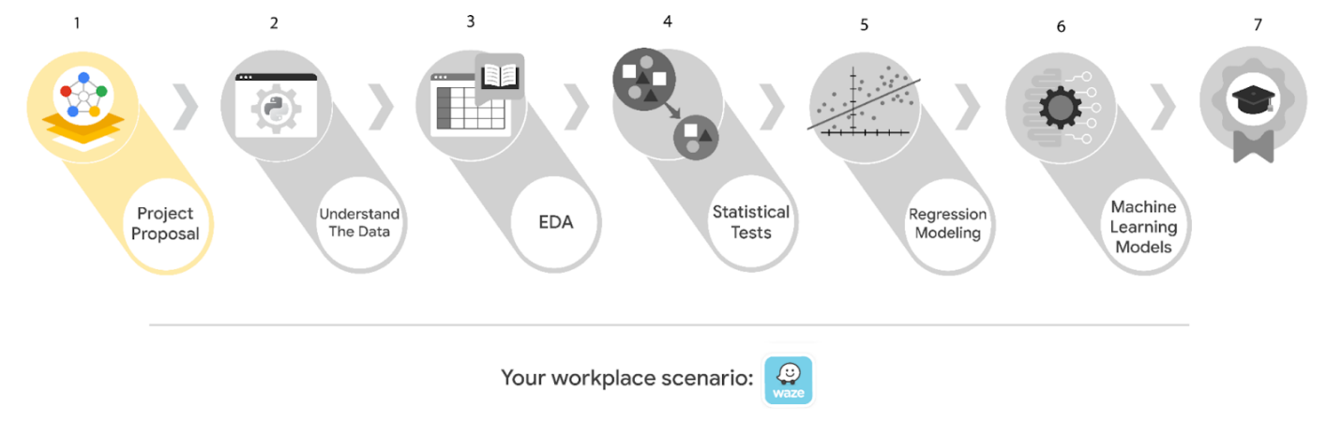

Learn more about the project, your role, and expectations in this reading.

## ****Background on the Waze scenario****

Welcome to your new role at Waze! We’re thrilled to have you on the data team!

Waze’s free navigation app makes it easier for drivers around the world to get to where they want to go. Waze’s community of map editors, beta testers, translators, partners, and users helps make each drive better and safer. Waze partners with cities, transportation authorities, broadcasters, businesses, and first responders to help as many people as possible travel more efficiently and safely.

You’ll collaborate with your Waze teammates to analyze and interpret data, generate valuable insights, and help leadership make informed business decisions. Your team is about to start a new project to help prevent user churn on the Waze app. Churn quantifies the number of users who have uninstalled the Waze app or stopped using the app. This project focuses on monthly user churn. In your role, you will analyze user data and develop a machine learning model that predicts user churn.

This project is part of a larger effort at Waze to increase growth. Typically, high retention rates indicate satisfied users who repeatedly use the Waze app over time. Developing a churn prediction model will help prevent churn, improve user retention, and grow Waze’s business. An accurate model can also help identify specific factors that contribute to churn and answer questions such as:

* Who are the users most likely to churn?
* Why do users churn?
* When do users churn?

For example, if Waze can identify a segment of users who are at high risk of churning, Waze can proactively engage these users with special offers to try and retain them. Otherwise, Waze may simply lose these users without knowing why.

Your insights will help Waze leadership optimize the company’s retention strategy, enhance user experience, and make data-driven decisions about product development.

### **Project background**

Waze’s data team is in the earliest stages of the churn project. The following tasks are needed before the team can begin the data analysis process:

* A project proposal identifying the following:
  + Organize project tasks into milestones
  + Classify tasks using the PACE workflow
  + Identify relevant stakeholders

### **Your assignment**

For your first assignment, Waze is asking for a project proposal that will create milestones for the tasks within this project. Remember to take into account your audience, team, project goal, and PACE stages of each task in planning your project deliverable.

***Note:*** This project's dataset was created for pedagogical purposes and does not represent Waze’s actual data.

## ****Team members at Waze****

As a new data analyst, you’ll work closely with a talented team of experienced data professionals. You’ll also collaborate with Waze co-workers outside the data team as your project requires.

### **Data team roles**

* Harriet Hadzic - Director of Data Analysis
* May Santner - Data Analysis Manager
* Chidi Ga - Senior Data Analyst
* Sylvester Esperanza - Senior Project Manager

### **Other roles in the scenario**

* Emrick Larson - Finance and Administration Department Head
* Ursula Sayo - Operations Manager

***Note:*** The story, all names, characters, and incidents portrayed in this project are fictitious. No identification with actual persons (living or deceased) is intended or should be inferred. The data shared in this project has been altered for pedagogical purposes.

The members of the data team have technical expertise in data analysis, and are familiar with  terms and concepts from statistics and machine learning. To communicate effectively with data team members, make sure your messages are clear, concise, and focused on key points.

Waze co-workers outside the data team may not have a background in data analysis, or be familiar with technical terms and concepts. When communicating with these co-workers, make sure to adjust your language to fit your audience, and clearly explain technical terms if necessary.

## ****Meeting notes****

After onboarding, you are given access to the company network and set up with a company email account (your first initial and last name, followed by @Waze).

Opening your inbox, you notice an email from your supervisor, May Santner.

**From:** “May Santner,” May@waze.com

**Subject:** Your first task: Review meeting notes

If you are reading this message, then your company accounts have been created! Now is the perfect time to get started. Last week, I attended an internal meeting with our leadership team about a new project. You’ll receive more information in the next few days, but I’d like you to be aware of some key points made by leadership. Here is an excerpt from my meeting notes. I’ve organized the points by the person who made them.

**Sylvester Esperanza, Senior Project Manager**

* The data team will need a global-level project document to outline project goals and milestones.
* We will need to generate some visuals to share with the Waze executives.

**Chidi Ga, Senior Data Analyst**

* The dataset has to be inspected before any analysis can begin.
* The data team needs to learn more about the data through exploratory data analysis (EDA).
* Eventually, our team will need to test the model to find out if it's delivering consistent results.

**Harriet Hadzic, Director of Data Analysis**

* Before we share any insights, we'll need to determine whether or not our model meets the project requirements.
* Once we finalize the model, I'll need to know the main talking points for our presentation to the leadership team.

**My thoughts and concerns…**

* I think it's best to use Python for this project. I'll have someone on my team set that up as soon as we have the project proposal in place.
  + It will be important to establish the relationship between key variables in the dataset. I'd suggest the data team consider hypothesis testing.

Review the meeting notes and proposed tasks from each team member to become familiar with the project’s context. I’ll ask you to identify project tasks and come up with a structure to guide the data team through this project. After our discussion about your experience in the Google certificate program, I know that your efficient communication style and strong problem-solving skills will help the data team achieve its goals.

There will be more details sent to you soon.

Welcome to the team,

May Santner

Data Analysis Manager

Waze

(P.S. Don’t forget about our Data Superstars discussion group. Our next session is this Friday at 3pm. Each month, the team gets together to discuss the work of an innovative and inspiring historical figure. This month, it’s Ada Lovelace, often considered the world’s first computer programmer. This event is also a great opportunity to get to know your new teammates - and, if you want, try the outstanding coffee in the Waze cafe! Please join us!)

## ****Specific project deliverables****

With this end-of-course project, you will gain valuable practice and apply your new skills as you complete the following deliverables:

* Course 1 PACE Strategy Document to plan your project while considering your audience members, teammates, key milestones, and overall project goal.
* Create a project proposal for the data team.

## ****Key takeaways****

The Google Advanced Data Analytics Certificate end-of-course project is designed for you to practice and apply course skills in a fictional workplace scenario. By completing each course’s end-of-course project, you will have work examples that will enhance your portfolio and showcase your skills for future employers.

# Activity Exemplar: Create your Course 1 Waze project

Here are completed exemplars along with an explanation of how the exemplars fulfill the expectations for the activity.

## Completed Exemplars



To review the exemplars for this course item, click the link below and select Use Template.

Link to exemplars:

* [Activity Exemplar: Course 1 PACE strategy document](https://docs.google.com/document/d/1vQAji1vQtK1-IdypxBg1g3K-dTu4mXcBlxC572eSwZM/template/preview)
* [Activity Exemplar: Waze project proposal](https://docs.google.com/document/d/1dinmmxGEm2MZYCq9xLjyinLT_rssBoEBEOnhDSxRPko/template/preview)

OR

If you do not have a Google account, you can download the exemplars directly from the attachment below.

[Activity Template\_ Course 1 PACE strategy document](https://d3c33hcgiwev3.cloudfront.net/BtLV1ZFlQPKi32BzS39BnQ_089c2429790244ebba25951e6991a8f1_Activity-Template_-Course-1-PACE-strategy-document.docx?Expires=1688083200&Signature=BkWpN~39dfwTmwdwkpsmgCwjxiPq8lFfoi3nxBGT6okyfQiDQ1Vl3Ry1b-NjwXbzNLx9o259Nwd216yX63raE-0BHK-5P0Q8YmdHw~hBmSBIGa2OTNeNRpFOZBri49sXCTkApZFAvOPzonSFpbrn7qqAlAYXPpOwGkrP5W5MfFA_&Key-Pair-Id=APKAJLTNE6QMUY6HBC5A" \t "_blank)

[DOCX File](https://d3c33hcgiwev3.cloudfront.net/BtLV1ZFlQPKi32BzS39BnQ_089c2429790244ebba25951e6991a8f1_Activity-Template_-Course-1-PACE-strategy-document.docx?Expires=1688083200&Signature=BkWpN~39dfwTmwdwkpsmgCwjxiPq8lFfoi3nxBGT6okyfQiDQ1Vl3Ry1b-NjwXbzNLx9o259Nwd216yX63raE-0BHK-5P0Q8YmdHw~hBmSBIGa2OTNeNRpFOZBri49sXCTkApZFAvOPzonSFpbrn7qqAlAYXPpOwGkrP5W5MfFA_&Key-Pair-Id=APKAJLTNE6QMUY6HBC5A" \t "_blank)

[Activity Exemplar\_ Waze project proposal](https://d3c33hcgiwev3.cloudfront.net/CemX1o2IT6ySW1I-jF4lFA_3942a0d4166245bcb7c32996542d80f1_Activity-Exemplar_-Waze-project-proposal.docx?Expires=1688083200&Signature=eAS-4LTwJrNHPl~tfcJhnS98MO~UIFsh5kd-iwl7eudj~AHegy-UcuWDk5fICIXBo0jbtCB4zOjLeq86tf50cAtpTpmaupBfFERpCBRahuHHv0UgIr3az8pKly-rluWwt-NjAqI176SZVrHWS5~rO83nNmjXAmloldlrhpDrtV0_&Key-Pair-Id=APKAJLTNE6QMUY6HBC5A" \t "_blank)

[DOCX File](https://d3c33hcgiwev3.cloudfront.net/CemX1o2IT6ySW1I-jF4lFA_3942a0d4166245bcb7c32996542d80f1_Activity-Exemplar_-Waze-project-proposal.docx?Expires=1688083200&Signature=eAS-4LTwJrNHPl~tfcJhnS98MO~UIFsh5kd-iwl7eudj~AHegy-UcuWDk5fICIXBo0jbtCB4zOjLeq86tf50cAtpTpmaupBfFERpCBRahuHHv0UgIr3az8pKly-rluWwt-NjAqI176SZVrHWS5~rO83nNmjXAmloldlrhpDrtV0_&Key-Pair-Id=APKAJLTNE6QMUY6HBC5A" \t "_blank)

## Assessment of Exemplar



### Course 1 PACE strategy document

Compare the exemplar to your completed PACE strategy document. Your responses may differ from the exemplar, but that is to be expected. What did you do well? Where can you improve? Use your answers to these questions to guide you as you progress through the course.

***Note:*** The exemplar represents one possible way to address the PACE questions and classify project tasks according to the PACE workflow. Yours may differ in certain ways, such as your specific responses to questions. What’s important is that you have a general idea of the order and PACE-stage classification for tasks in the data analysis process.

Your replies to the Course 1 PACE strategy document should:

* Be relevant to Waze project goals and related to data science
* Demonstrate your understanding of the business scenario
* Communicate the reasoning behind your decisions to pair PACE stages with specific tasks



### Course 1 Waze project proposal

Compare the exemplar to the Waze project proposal you completed. Review your work using each of the criteria in the exemplar. What did you do well? Where can you improve? Use your answers to these questions to guide you as you progress through the course.

***Note:*** The exemplar represents one possible way to complete the Waze project proposal. Yours may differ in certain ways, such as specific task assignments, PACE stages, or relevant stakeholders. What’s important is that you have an overall understanding of the purpose and organization of project proposals for data-driven work.

Your project proposal should:

* Clearly communicate the overall project goal
* Identify key tasks, milestones, and stakeholders